**Chapter 11: Environmental Chemistry - Air**

**All Lectures Uploaded on YouTube:**

[**https://tinyurl.com/fkm9-chemistry**](https://tinyurl.com/fkm9-chemistry)



**Introduction to Atmosphere**

The atmosphere is the envelope of gases and water vapour surrounding the Earth.

Air is a mixture of gases including nitrogen, oxygen, carbon dioxide, noble gases, and water vapor.

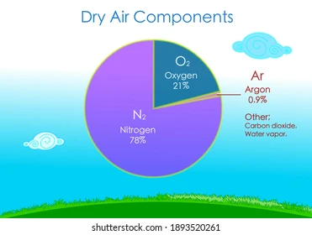

**11.1. Composition of Atmosphere**

The composition of dry air (by volume):

* 78% Nitrogen
* 21% Oxygen
* 1% Other gases (Argon, CO₂, Neon, Helium, Methane, Krypton, Hydrogen, etc.)

Water vapour content varies from place to place (e.g., deserts have very little, tropical rainforests up to 4%).

The envelope of gases and water vapour surrounding the planet Earth is called the atmosphere.

**What are Pollutants?**

Pollutants are harmful substances in air, water, or soil that negatively affect the environment, health, and quality of life.

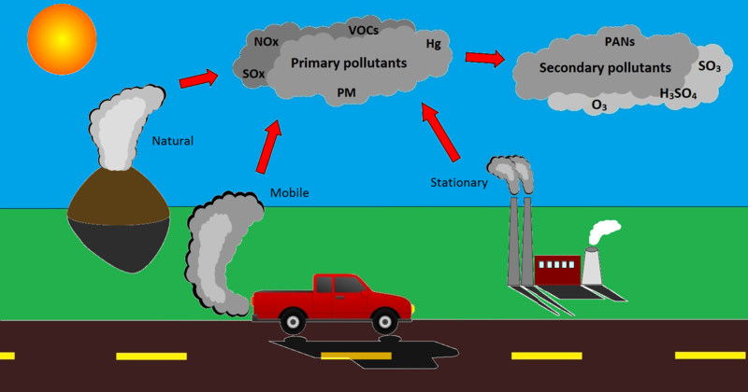

They result from human activities such as industry, agriculture, and waste disposal.

Examples: industrial waste, pesticides, dust, smoke, carbon monoxide, nitrogen dioxide, sulphur dioxide, ozone, lead-based paints.

**11.2. Air Pollutants**

Pollutants are things like industrial wastes, herbicides, pesticides, insecticides, particles of dust and smoke, carbon monoxide, nitrogen dioxide, sulphur dioxide, ozone and lead containing paints. These things have a negative impact on the environment. Such substances affect the environment as a result of human activity.

Anything that is in the air, water or soil which has a harmful effect on some part of the environment is called a pollutant.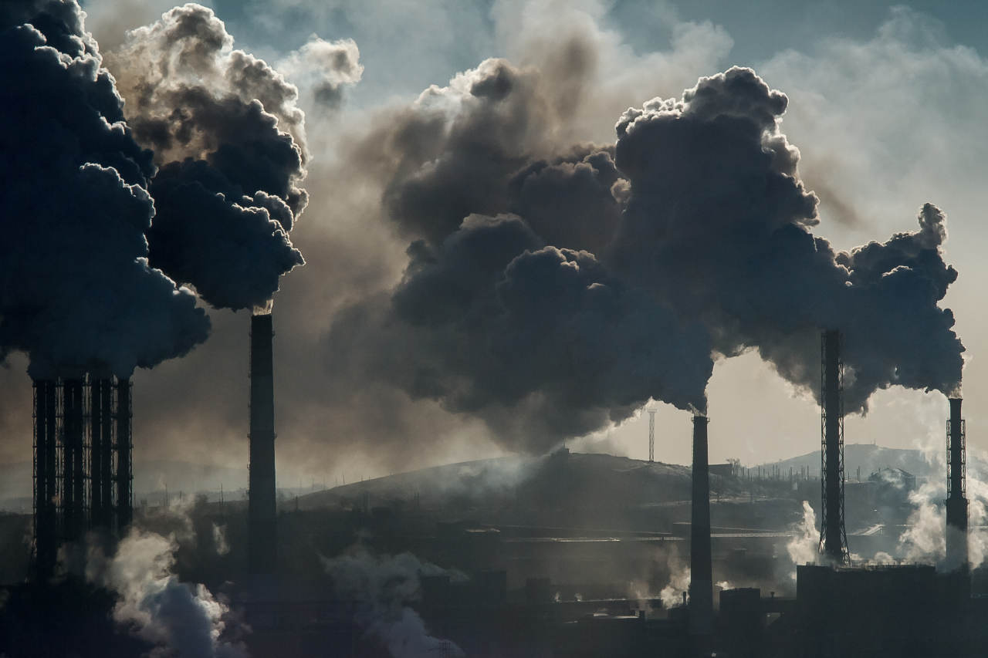

**11.2.1. Sulphur Oxides (SOₓ)**

**Source:** Burning of fossil fuels (power plants, vehicles, industries, generators, residential heating).

**Effects:**

o Irritates respiratory system.

o Aggravates asthma, bronchitis, emphysema, and lung diseases.

o Causes acid rain and haze.

o Fades colours of materials (e.g., silk clothes).

**11.2.2. Nitrogen Oxides (NOₓ)**

**Main oxides:** Nitric oxide (NO) and nitrogen dioxide (NO₂).

**Source:** Burning fossil fuels in vehicles, power plants, industries.

**Effects**:

o Highly toxic.

o Causes acid rain, photochemical smog.

o Leads to headaches and respiratory problems.

**11.2.3. Carbon Dioxide (CO₂)**

**Source:** Naturally present, but increased by human activities (burning fossil fuels, deforestation, industrial processes).

**Effect:** Major contributor to climate change and global warming.

**11.2.4. Carbon Monoxide (CO)**

**Source:** Incomplete combustion of fuels (vehicles, industrial processes, residential heating).

**Effects:**

o Toxic, colourless, odourless gas.

o Binds with hemoglobin to form carboxyhemoglobin, reducing oxygen transport. o Can cause unconsciousness, suffocation, and death.

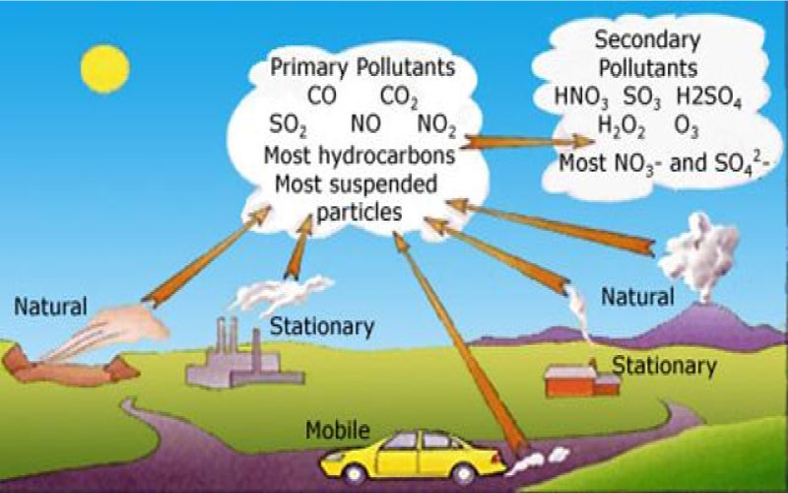

**Particulate Matter**

**Source:** Incomplete combustion, soot, smoke, dust, industrial emissions.

**Effects:**

o Fine particles can penetrate deep into lungs.

o Causes respiratory problems, lung cancer, and other health issues.

**11.2.5. Methane (CH₄)**

**Sources:**

o Decomposition of vegetation and waste.

o Wetlands, rice fields, landfills.

o Digestive processes of livestock (cows, goats, sheep) through belching and flatulence.

**Effect:** Contributes to global warming and climate change.

**11.2.6. Ground-Level Ozone (Smog)**

**Formatio**n: Secondary pollutant from reactions between nitrogen oxides and volatile organic compounds (VOCs) in sunlight (photochemical reactions).

**Sources:** Industrial and urban areas with car and industrial emissions.

**Effects:**

o Irritates respiratory system.

o Causes asthma and other respiratory issues.

o Damages vegetation, reduces crop yield, harms forests.

**Key Chemical Reactions (Photochemical Smog Formation)**

1. Sunlight breaks NO₂:

NO2 → NO + O

2. Atomic oxygen reacts with O₂ to form ozone:

O + O2 → O3

Summary Table:

| **Pollutant** | **Major Sources** | **Health & Environment Effects** |
| --- | --- | --- |
| **SOₓ** | Fossil fuel combustion | Respiratory issues, acid rain, haze |
| **NOₓ** | Vehicles, power plants, industries | Toxic, acid rain, smog, respiratory problems |
| **CO₂** | Burning fuels, deforestation | Global warming, climate change |
| **CO** | Incomplete combustion | Reduces oxygen in blood, fatal |
| **Particulates** | Smoke, dust, soot | Lung cancer, respiratory diseases |
| **Methane (CH₄)** | Livestock, waste, wetlands | Contributes to global warming |
| **Ground-level O₃** | NOₓ + VOCs + sunlight | Respiratory irritation, crop damage, smog |

**11.3. Sources of Air Pollution**

Air is considered polluted when it contains harmful particles and gases.

Pollution can arise from:

**11.3.1. Natural Sources**

1. Forest fires – release smoke and dust particles.

2. Dust storms – release large amounts of dust into the air.

3. Volcanoes – emit ash, dust, and poisonous gases (e.g., sulfur dioxide).

4. Termites and livestock (cows, etc.) – release methane during digestion.

5. Electrical discharges (lightning) – produce nitrogen oxides in the atmosphere.

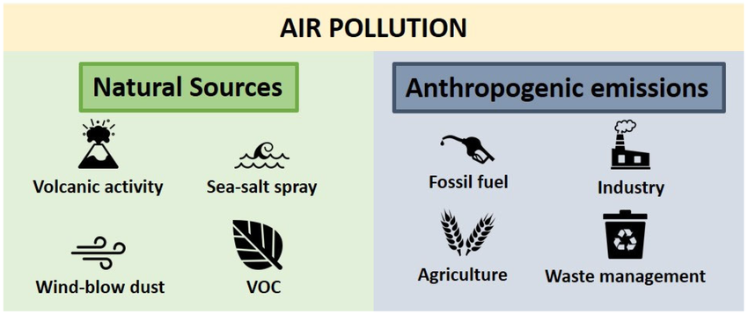

**11.3.2. Human Activities**

Primary source: Burning of fossil fuels (coal, petroleum, natural gas).

Major contributors:

* Vehicles – nearly half of all air pollution comes from cars and motor vehicles.
* Factories and power plants – burn coal or oil, releasing poisonous gases.
* Incineration – releases CO, NOₓ, SOₓ.

**Key Chemical Equations for Pollutant Formation:**

Carbon monoxide (from incomplete combustion):

C(s)+O2(g)(limited)⟶CO(g)

Sulphur dioxide:

S(s)+O2(g)⟶SO2(g)

Nitric oxide:

N2(g)+O2(g)⟶2NO(g)

Nitrogen dioxide:

2NO(g)+O2(g)⟶2NO2(g)

Air Pollutants – Properties, Sources, and Effects

| **Pollutant** | **Physical Properties** | **Sources** | **Harmful Effects** |
| --- | --- | --- | --- |
| **Carbon monoxide** | Colourless, odourless, poisonous | Incomplete burning of wood/fuels, vehicle exhaust | Headache, brain  damage, death |
| **Sulphur dioxide** | Colourless,  unpleasant/irritating odour | Power stations, industries using fossil fuels | Breathing difficulties, bronchitis,  emphysema, lung cancer, acid rain, greenhouse effect |
| **Oxides of nitrogen** | NO: colourless, odourless, soluble in water;  NO₂: reddish-brown, pungent, soluble | Motor vehicles, power stations, industries using fossil fuels | Cough, headaches, lung diseases, acid rain, greenhouse effect (global warming) |

**11.4. Global Warming**

∙ Examples: Water vapour, methane (CH₄), carbon dioxide (CO₂).

∙ Source of increase: Burning fossil fuels, deforestation, industrial processes.

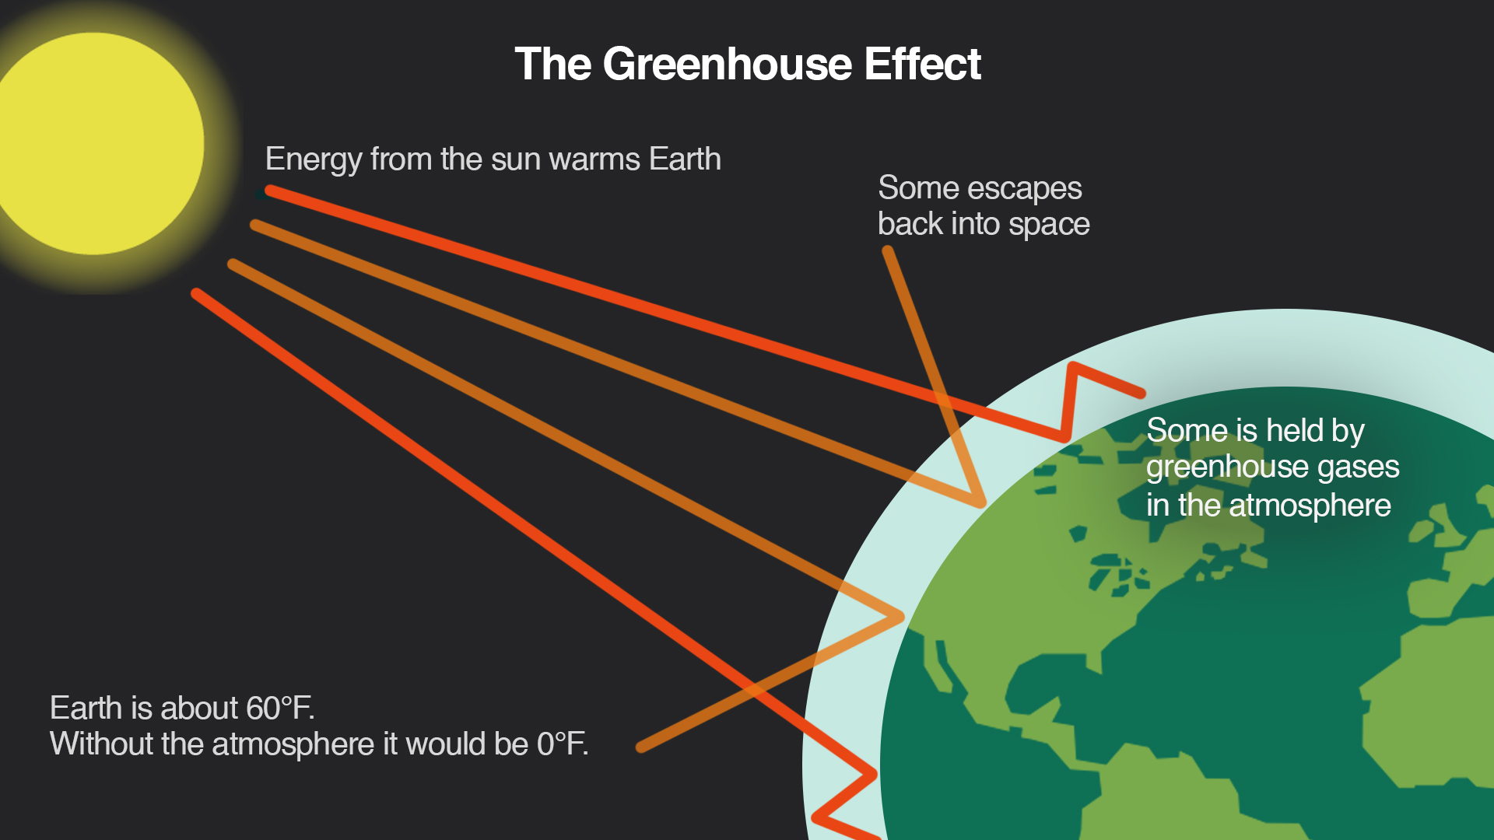

**How the Greenhouse Effect Works**

1. Sunlight reaches Earth → absorbed by surface (land, oceans, vegetation).

2. Earth warms up → emits energy as infrared radiation.

3. Greenhouse gases absorb this infrared radiation.

4. Gases re-radiate some energy back to Earth’s surface (like a blanket).

5. Result: Trapping of heat in the lower atmosphere → warming effect.

Analogy: A greenhouse (made of glass/transparent polymer) allows sunlight in but traps heat inside, raising temperature by 10°C–15°C compared to outside.

**Natural vs. Enhanced Greenhouse Effect**

∙ Natural greenhouse effect: Essential for life; without it, Earth would be too cold.

∙ Enhanced greenhouse effect: Caused by human activities increasing greenhouse gas concentrations → leads to global warming.

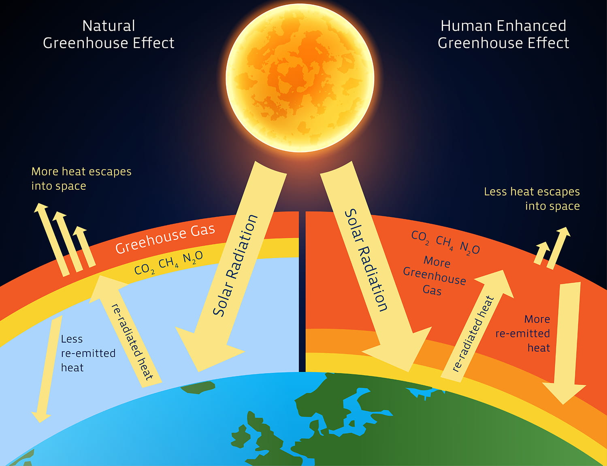

**Consequences of Global Warming**

If global warming continues:

1. Increase in Earth’s temperature.

2. Climate change – altered rainfall patterns:

o Increased flooding in some regions.

o Drought in others.

3. Melting of polar ice → rise in sea levels.

4. Hotter atmosphere.

**Sources & Impacts of Air Pollution & Global Warming**

| **Topic** | **Key Points** |
| --- | --- |
| **Natural Sources** | Volcanoes, forest fires, dust storms, livestock, lightning |
| **Human Sources** | Vehicles, industries, power plants, incineration, deforestation |
| **Major Pollutants** | CO, SO₂, NOₓ, particulates, methane, ozone |
| **Greenhouse Gases** | CO₂, CH₄, water vapour |
| **Greenhouse Effect** | Natural process; enhanced by human activities → global warming |
| **Global Warming Effects** | Rising temps, climate change, sea-level rise, extreme weather |

**11.5. Acid Rain and Its Effects**

**What is Acid Rain?**

* Normal rainwater has a pH of 5.6 due to dissolved carbon dioxide.
* Acid rain is defined as rain with a pH less than 5.6.
* It is caused by atmospheric pollutants such as sulphur dioxide (SO₂) and nitrogen oxides (NOₓ) dissolving in rainwater, forming acids.

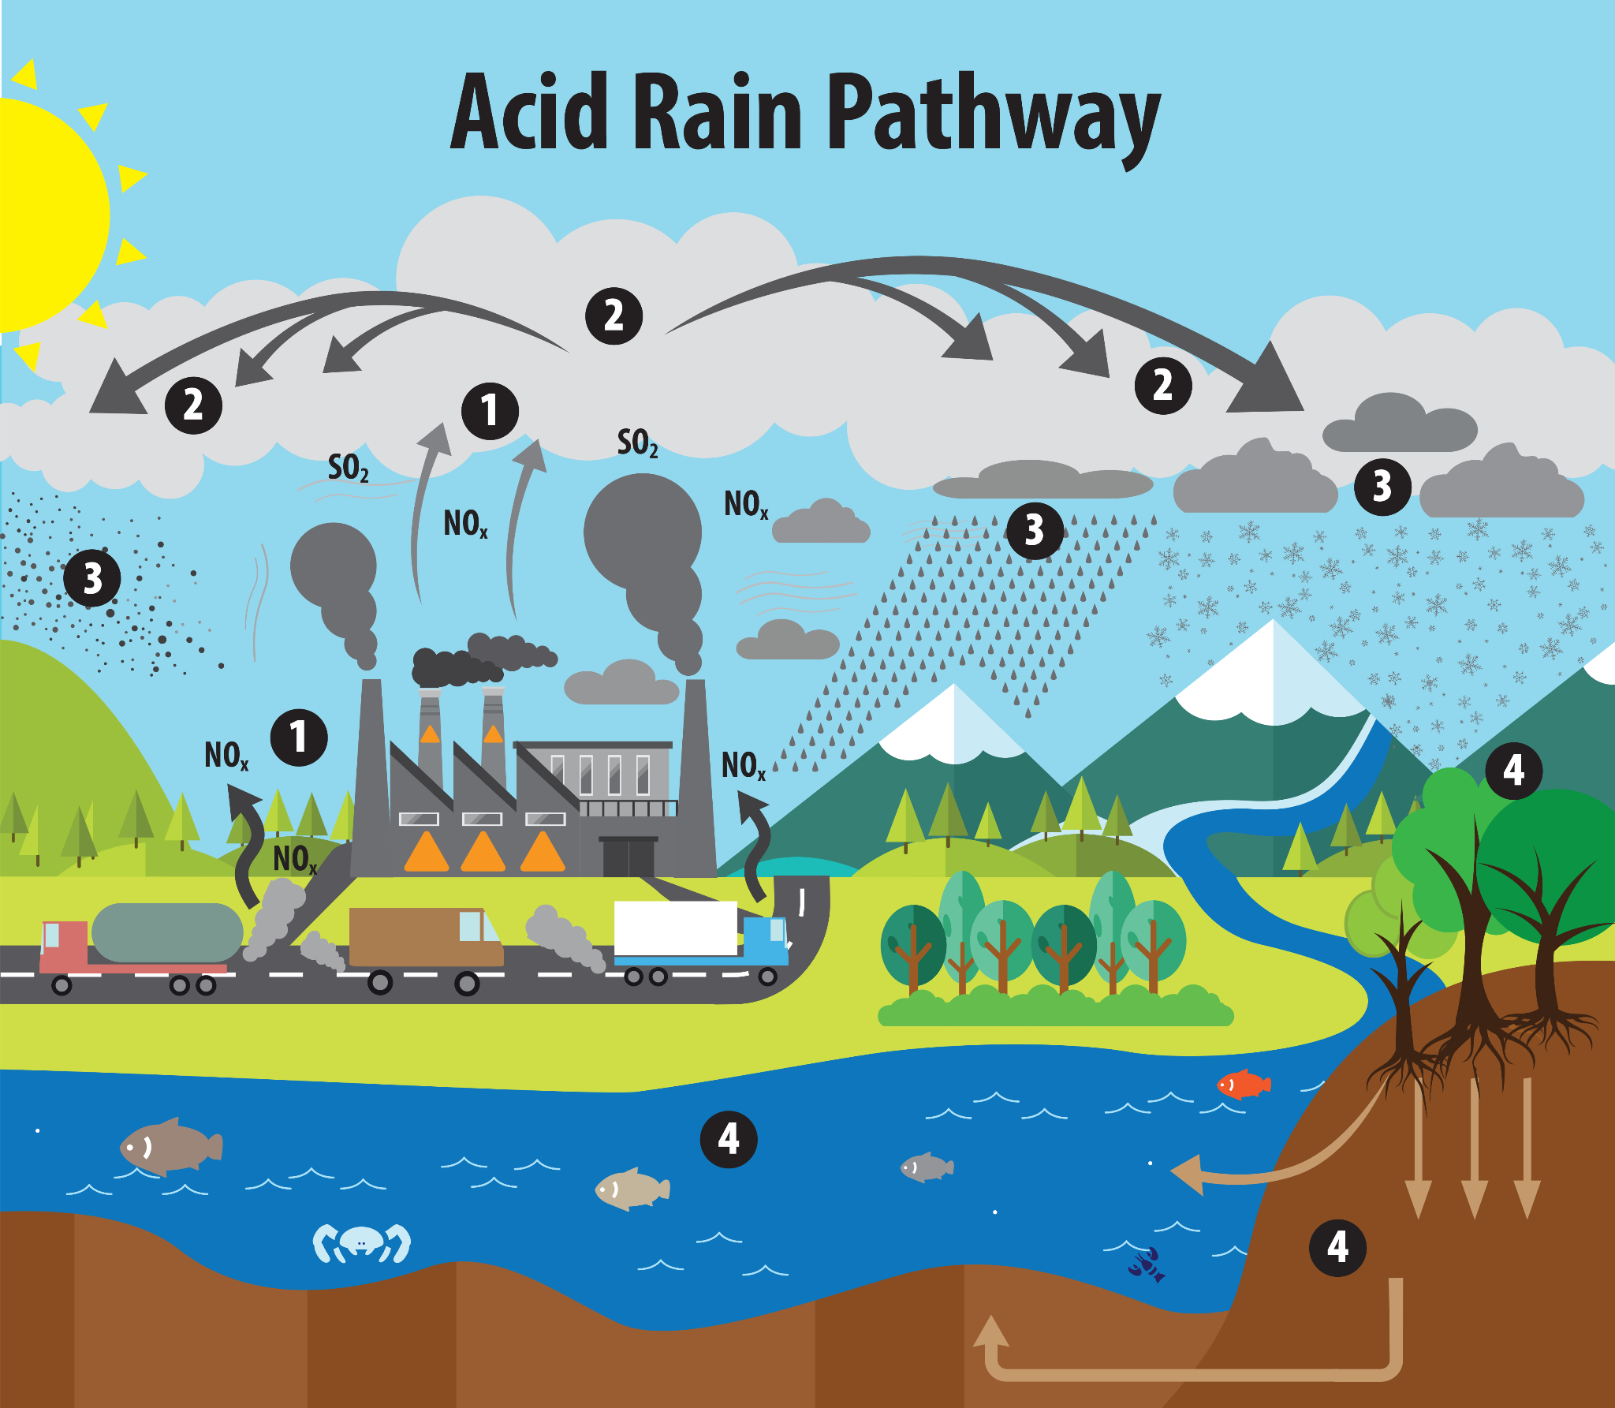

**Formation of Acid Rain**

1. From Sulphur Dioxide:

2SO2(g)+O2(g)⟶2SO3(g)

SO3(g)+H2O(l)⟶H2SO4(aq)

2. From Nitrogen Dioxide:

2NO2(g)+3O2(g)+2H2O(l)⟶4HNO3(aq)

∙ NO₂ also catalyzes the oxidation of SO₂ to SO₃.

∙ Acid rain can have a pH as low as 2.1 (more acidic than vinegar or lemon juice).

**Effects of Acid Rain**



1. Corrosion of Metals:

Fe(s)+H2SO4(aq)⟶FeSO4(aq)+H2(g)

2. Damage to Stone Structures (Marble/Calcium Carbonate):

CaCO3(s)+H2SO4(aq)⟶CaSO4(aq)+H2O(g)+CO2(g)

3. Environmental Damage:

o Kills aquatic life (fish).

o Destroys forests and vegetation.

o Makes lakes/rivers too acidic for survival.

4. Long-range transport: Acid rain can fall hundreds of kilometers from its source.

**11.6. Catalytic Converters**

**Function**

∙ Installed in vehicle exhaust systems.

∙ Use catalysts (platinum, palladium, rhodium) to convert harmful gases into less harmful substances.

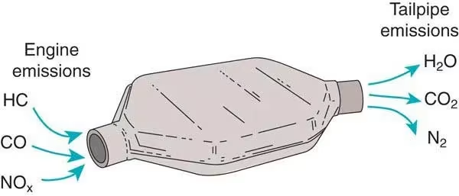

**Chemical Conversions**

1. CO → CO₂

2. NO → N₂ + O₂

3. Unburned hydrocarbons → CO₂ + H₂O

Example Reaction:

2NO+2HC/CO→N2+2CO2+H2O

**Importance**

∙ Reduces emissions of CO, NOₓ, and hydrocarbons.

∙ Recommendation: Governments (like Pakistan) should enforce installation in all vehicles.

**11.7. Strategies to Reduce Environmental Problems**

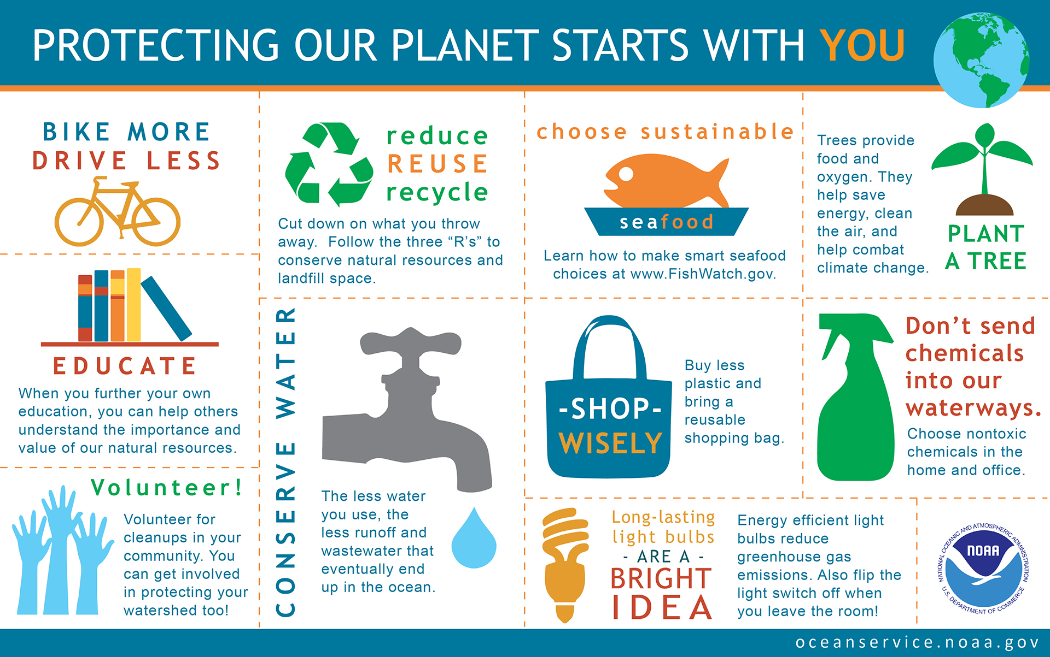

**Climate Change Mitigation**

**1. Transition to Renewable Energy:**

o Solar, wind, hydro, geothermal.

**2. Energy Efficiency:**

o Promote energy-efficient technologies.

**3. Reduce Transport Emissions:**

o Electric vehicles, public transport, walking, cycling.

**Afforestation & Reforestation**

**1. Planting Trees:**

o Increases CO₂ absorption via photosynthesis.

o Reduces soil erosion, increases biodiversity.

**2. Forest Regeneration:**

o Restores damaged forests, enhances carbon sequestration.

**Sustainable Land Use**

**1. Sustainable Agriculture:**

o Organic fertilizers, reduced pesticides.

o Lowers emissions, protects water and soil.

**2. Reduce Deforestation:**

o Protects carbon sinks.

**Low-Carbon Economy**

**1. Hydrogen Economy:**

o Hydrogen as clean fuel for transport/industry.

**2. Circular Economy:**

o Minimize waste, promote recycling.

**International Cooperation**

**1. Paris Agreement:**

o Limit global warming to below 2°C, aim for 1.5°C.

**2. Policy Support:**

o Incentives for renewables, emission regulations.

**11.7.2 Strategies To Solve Acid Rain**

**Acid Rain Mitigation**

**1. Emission Control:**

o Reduce SO₂ and NOₓ from industries/vehicles.

**2. Flue Gas Desulfurization:**

o Scrubbers in power plants remove SO₂.

**3. Low-Sulphur Fuels**

o Promoting low sulphur fuels can also minimize the amount of sulphuric acid in the atmosphere causes acid rain

**Catalytic Converters in Vehicles**

The promotion of catalytic converters in vehicle exhaust systems can reduce emissions of platinum, harmful gases and volatile organic compounds. Converters contain catalysts such as substances palladium, and rhodium, which transform harmful gases into less harmful substances.

**11.8. Photosynthesis**

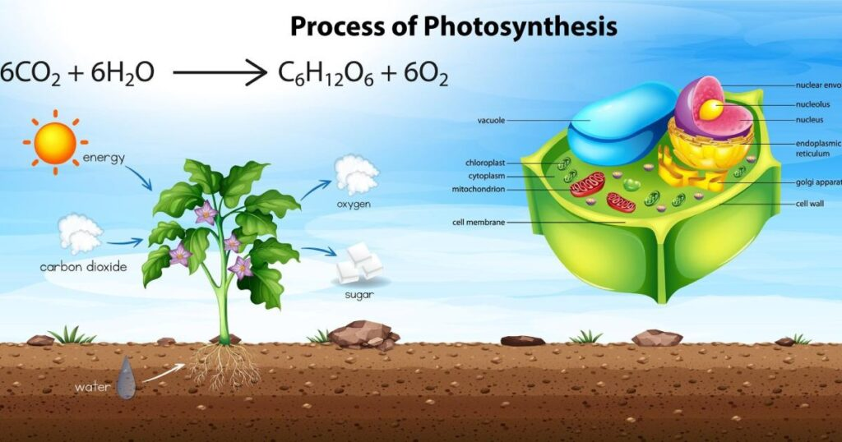

Equation:

6CO2+6H2O (sunlight, chlorophyll) → C6H12O6 + 6O2

∙ Plants convert CO₂ + H₂O → glucose + O₂ using solar energy.

∙ Role in Carbon Cycle: Removes CO₂ from atmosphere, produces oxygen and organic matter.

**11.9. Personal Protective Measures Against Pollution**

**Masks & Respiratory Protection:**

o N95 masks: Filter particles (dust, smoke).

o Gas masks: Activated carbon filters absorb gases/VOCs.

o Use certified masks as per instructions.

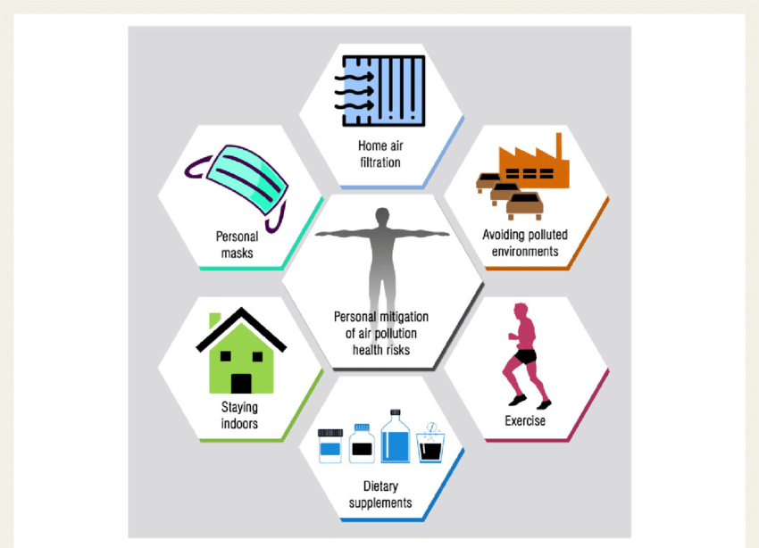

**Air Quality Indices (AQI):**

o Numerical/color-coded systems indicate pollution levels.

o Helps in taking precautions.

**Carbon Monoxide Detectors:**

o Installed in homes/offices.

o Alerts to dangerous CO levels.

o Enables ventilation/evacuation.

**11.10 Risk Factors**

**Long-term Exposure to Pollutants:**

NOₓ, SO₂, PM, ozone → asthma, lung cancer, COPD.

**Smoking:**

Damages lungs, increases COPD/cancer risk.

Harmful to smokers and non-smokers (second-hand smoke).

**Indoor Pollution:**

Poor ventilation, mold, dust mites, pets, chemicals → allergies, asthma.

**Allergens:**

Pollen, mold spores, pet dander → respiratory allergies, asthma.

**Climate Change:**

Worsens air quality, increases wildfires, alters pollen seasons.

Aggravates respiratory symptoms.

| **Topic** | **Key Points** |
| --- | --- |
| **Acid Rain** | pH < 5.6, from SO₂/NOₓ, damages structures, ecosystems, aquatic life. |
| **Catalytic Converters** | Use Pt/Pd/Rh to convert CO→CO₂, NO→N₂, HC→CO₂+H₂O. |
| **Climate Strategies** | Renewables, afforestation, sustainable agriculture, circular economy. |
| **Acid Rain Solutions** | Emission control, scrubbers, low-sulphur fuels, catalytic converters. |
| **Photosynthesis** | Removes CO₂, produces O₂, key to carbon cycle. |
| **Personal Protection** | N95/gas masks, AQI monitoring, CO detectors. |
| **Risk Factors** | Pollution, smoking, indoor allergens, climate change → respiratory diseases. |



